16. Sexual Reproduction and Development in Animals II  *(RHM: Chapter 50)*

______________________________________________________________________________

V. Gastrulation *(1173-1175)*

A. Definition and Functions

B. In Deuterostomes

C. In Protostomes

VI. Early Amphibian Development *(1169-1175)*

A. Structure of Egg

B. Cleavage

C. Gastrulation

VII. Early Avian Development *(1169-1175)*

A. Fertilization

B. Cleavage

C. Gastrulation

VIII. Early Mammalian Development *(1176-1181)*

A. Fertilization

B. Cleavage

C. Implantation

D. Extracellular Membranes

IX. Morphogenesis and Organogenesis *(1181-1185)*

A. Introduction

B. Morphogenetic Movements

C. Importance of Triploblastic Construction

16-1

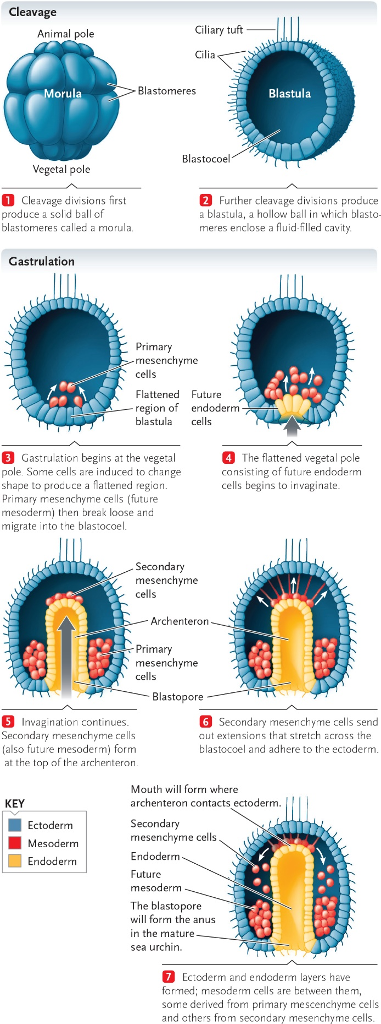

16-2

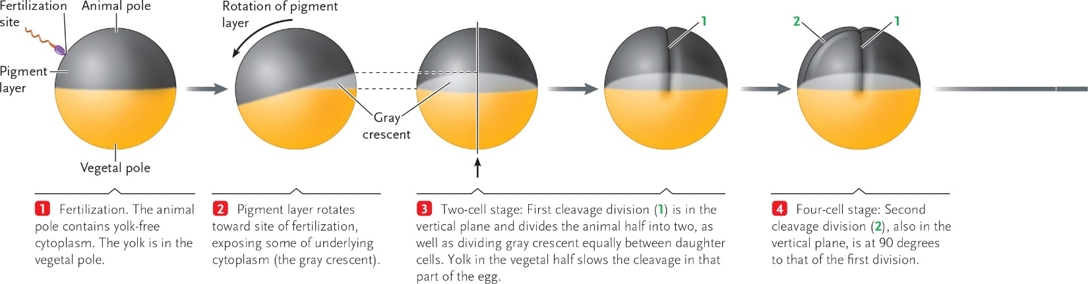

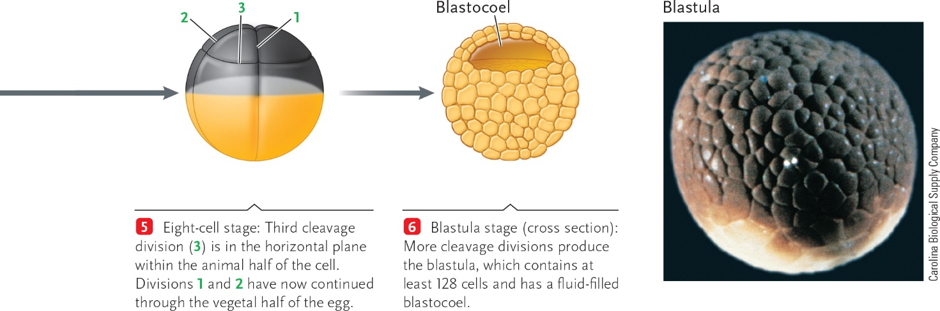

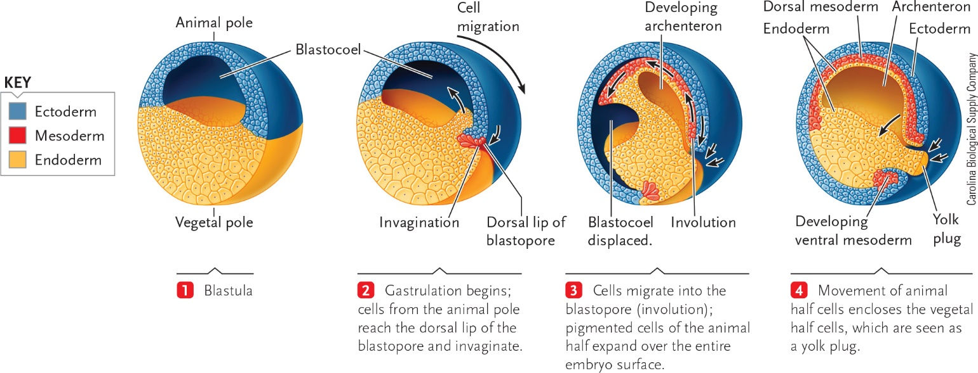

16-3

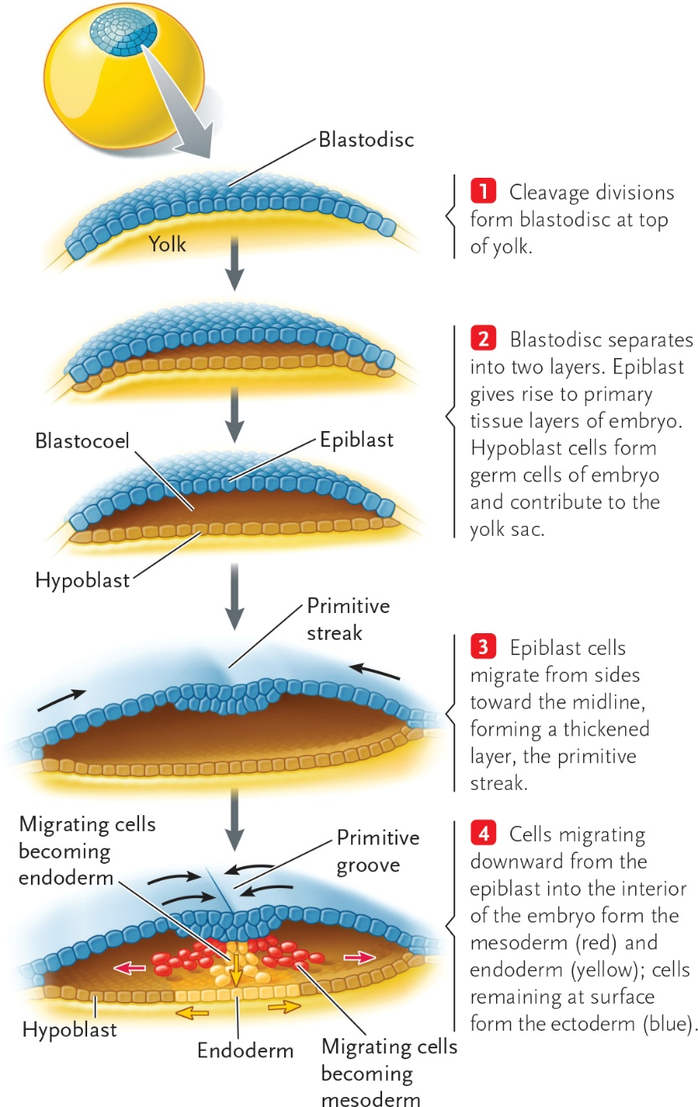

16-4

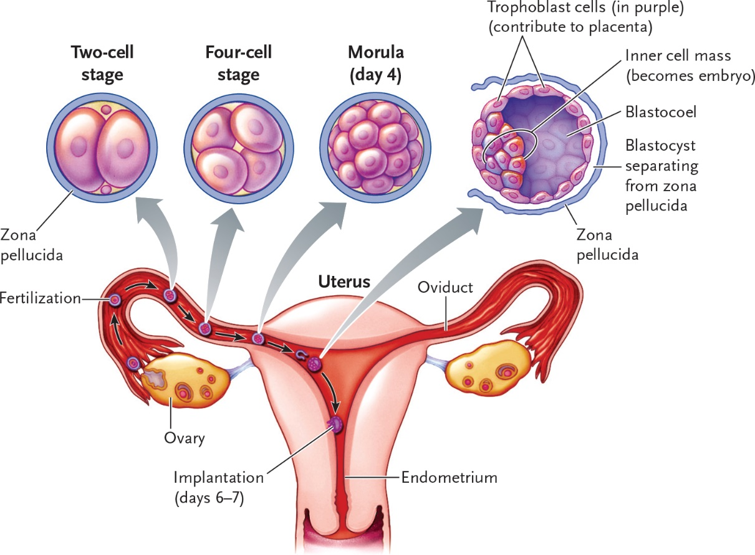

16-5

